## Your Dataset

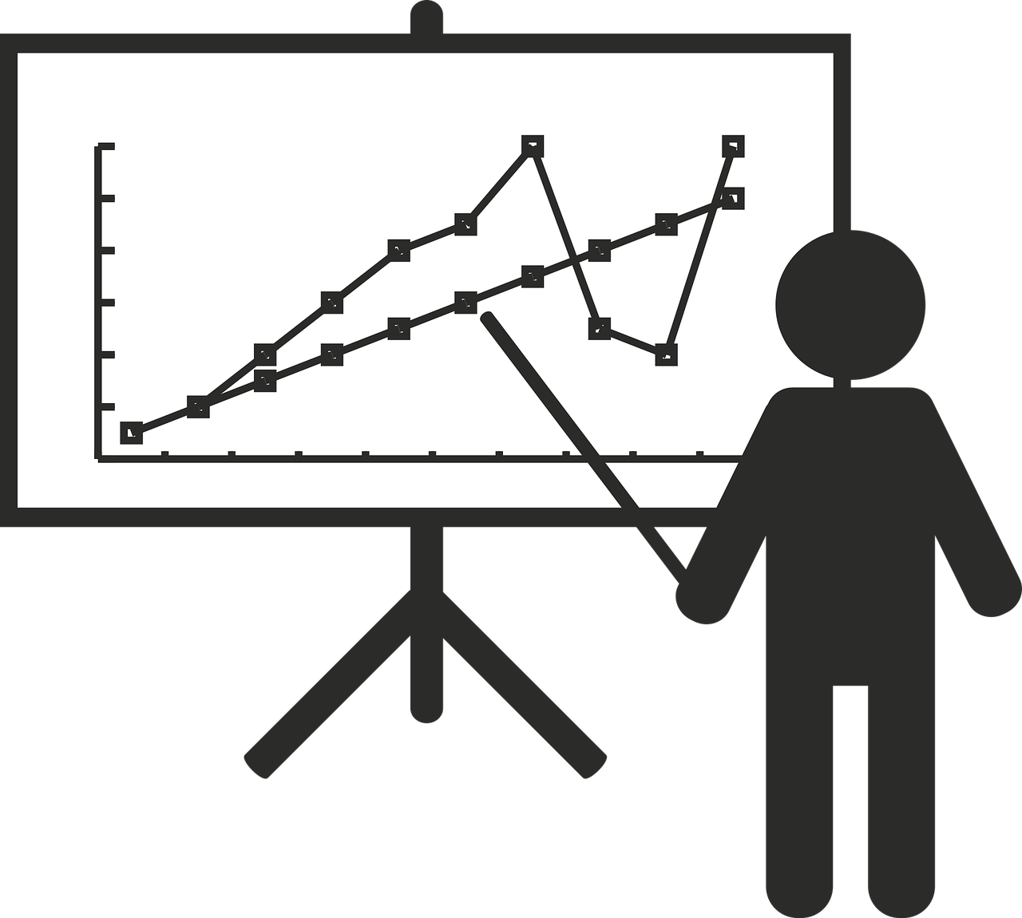

In this lesson, you will collect, explain, and present the important data and details of your project. The next few exercises will lead you through this step in the data science life cycle.

Answer the following questions about the dataset you used in your project.

1. In one or two sentences, explain your dataset. What information does it contain?
2. Why did you choose your dataset?
3. Where did the data in the dataset come from? Explain why it is reliable and can be trusted. List the source if possible.
4. In more detail, describe your dataset. ​Tell what variables are represented in the columns, and what kind of data values each variable has.
5. Name the grouped samples or filtered tables that you used for your project?